**B.Tech. Final Year Project (2019-2023)**

**Zeroth Review Report**

**Date:** 30/01/2023

**Group No:** 24

**Names /Roll Nos.:** Manav Mohata (106119071),

Rajneesh Pandey (106119100),

Satyarth Pandey (106119112)

**Guide's Name/Dept.:** Dr. B. Shameedha Begum

**Title:** Classification of EEG signals using feature level graph embedded method

**Scope:**

Motor imagery BCIs based on EEG have gained popularity in clinical applications due to their advantages of low clinical risk, economy, convenience, and no requiring stimulus targets. For example, motor imagery BCIs have been applied to control intelligent devices such as electric wheelchairs, hand exoskeletons, artificial prosthetic limbs, and robot movement.

Recently, the success of deep learning has driven the development of motor imagery brain-computer interfaces (MI-BCIs) based on electroencephalography (EEG). However, unlike image or language data, motor imagery EEG signals are of multielectrodes with topology information. Few studies have been done on motor imagery classification involving graph embeddings to integrate graph topology information into feature maps.

Specifically, time-domain features are obtained by convoluting raw EEG signals for each electrode. Then, the adjacent matrix, conceptualized as a graph filter, can be used as time-domain features to embed the topology information. We can also use this adjacency matrix in different brain network connectivities for different subjects. Further, this method will be evaluated on benchmark EEG datasets for motor imagery classification.

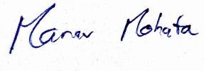 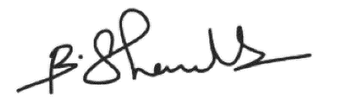

**Signature of Students** **Signature of Guide**